CENG311 PROGRAMMING ASSIGMENT 1
Elif Turhan – 240201001

node_creation:
make sbrk syscal with 16 bytes for new node allocation
then puts the value,left,right and parent adreess
for a new node except value all will be 0
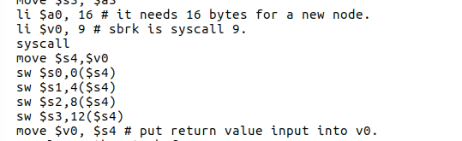
build:
to loop in aray i initialize my array index 2 because i already created root outside the build function
then if it dont come across -9999 value it will continue to go insert function

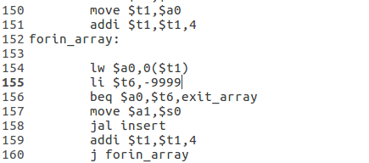

insert:
for given value i will create new node for my insertation and save its address
and check the value according to node value
if < go left child of node
if > go right child of node
when find empty space to put its own, insert_left or insert_right will store new node address
to current node left or right child space
find:
take the given value and check if it can be in right side or left side of node
then continue check if it came across its equailent value(go to hallelujah) or no reamining child it is stop(goes exit_tree) and sets returning values with reuiqrements
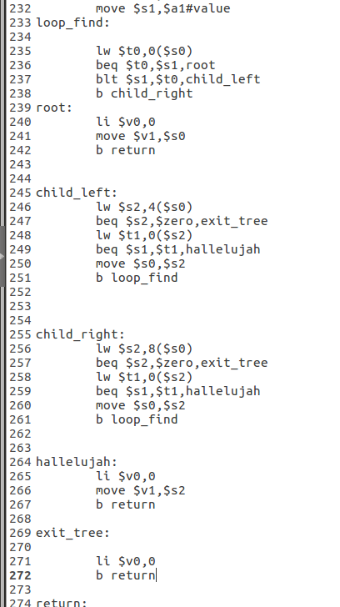

findMinMax:
check if given value 0 or 1 then goes min or max label according to given value
min:
for min go the leftest child it understand if there is no left child then it mean previous left is min(goes eureka)
max:
for max go the rightest child it understand if there is no right child then it mean previous right is max(goes eureka)
eureka:
loads needed values to return registers
